Topic Exploration Pack

CPU Architecture Interactive Resource
Objectives
By completing this activity you will know the structure of a typical processor and be able to name and give the function of key components.

Activity 1
You are going to make an interactive resource to help you to learn and remember the main components of a typical processor and their function.
You can use resources to produce an interactive poster to help you to remember names and functions of components. You should include:
- ALU
- Control Unit
- Program Counter
- Accumulator
- Memory Data Register
- Memory Address Register
- Current Instruction Register
As an alternative activity, you could produce your resource in the form of an interactive presentation.
You could also produce a mobile phone app for Android using the software MIT App Inventor.

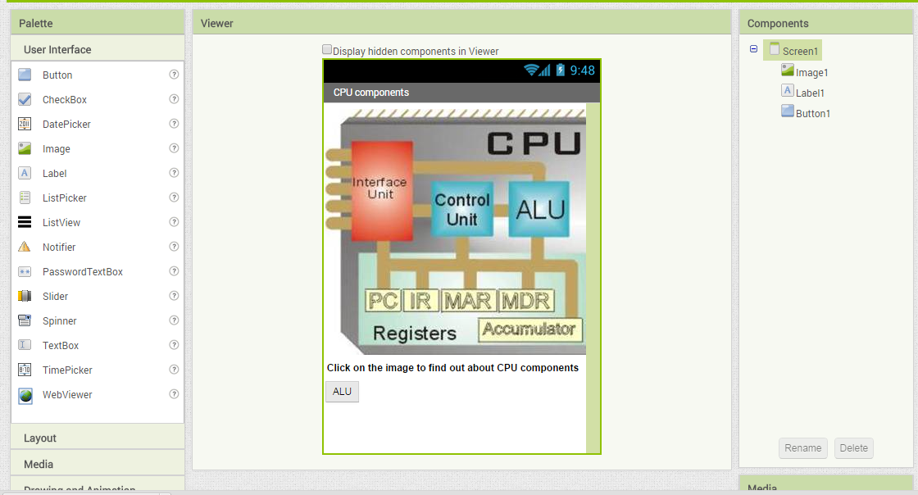
Fig 1 MIT App Inventor being used to create a revision app
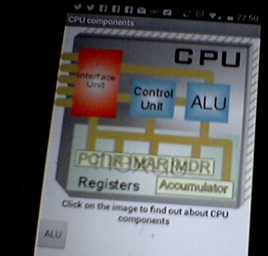
Fig 2 App Inventor mobile app being tested during development
Peer assessment
Once you have completed your interactive resource, ask a fellow student to review it for you.
Questions to answer
- This type of processor structure is also called the Von Neumann architecture. Research the work of John von Neumann.

- Is the control unit a necessary component? Do any processors not have one?

- What determines the size of a register within this CPU?

- What other features, found in modern processors, are lacking in this simplified model?

Benchmark testing a CPU
Objectives
In completing this activity you will understand how CPU performance is measured.
Resources
Downloaded benchmark test software from http://novabench.com/ or http://www.sisoftware.co.uk/
A Windows PC.
A Raspberry Pi computer.

Activity 2
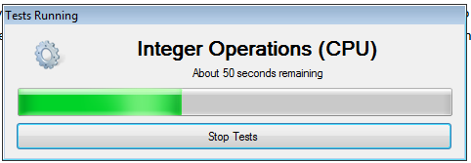
In this activity you are going to test the capability of a processor. Firstly, you will need to download special software for carrying out a benchmark test. Run the software to test your system:

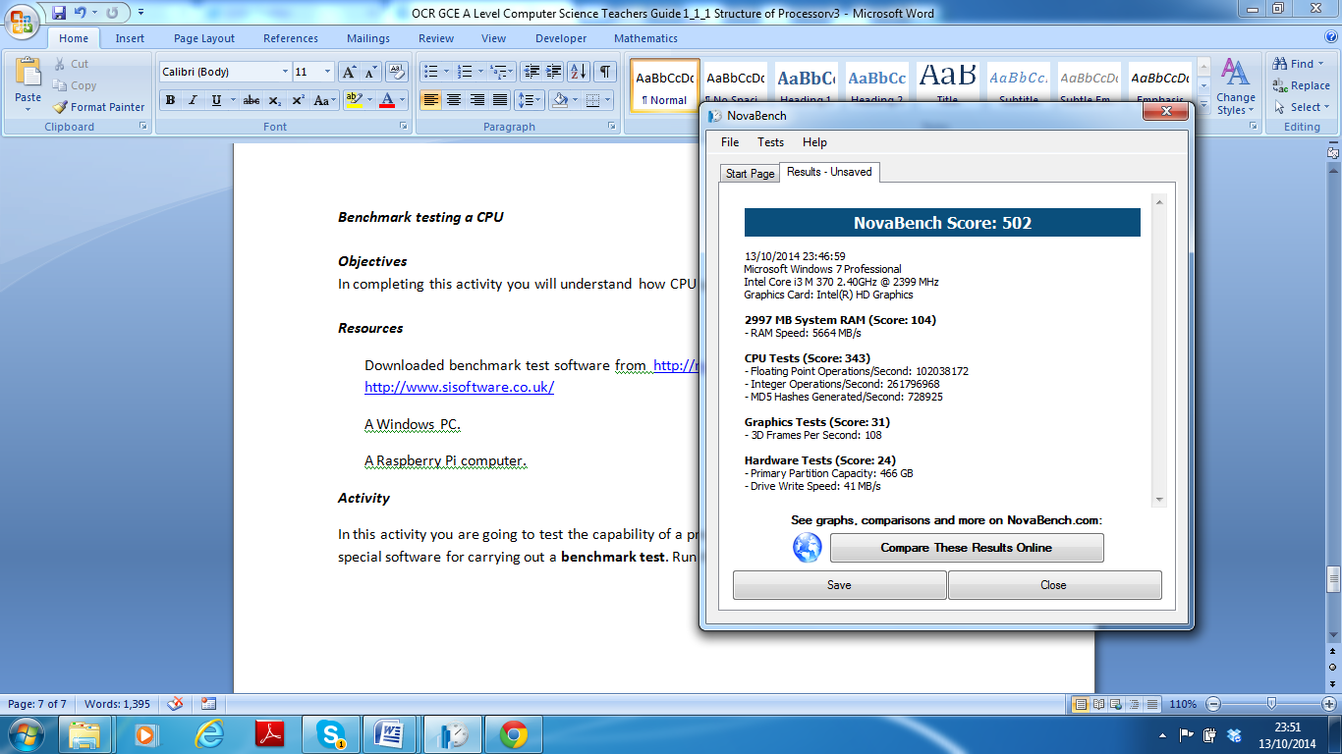
Floating Point Operations (FLOPS) and Integer Operations/Second are measures of how many calculations the processor can perform. An MD5 Hash calculation is quite demanding for the CPU so is another measure of performance.
Fig 3 Benchmark tests using Novabench
- You can also benchmark a Raspberry Pi computer by downloading tools from http://www.roylongbottom.org.uk/Raspberry%20Pi%20Benchmarks.htm . The Raspberry Pi can also be overclocked which allows performance to be enhanced by increasing the clock speed of the CPU.
- Benchmark test your computer and note down the results.

Questions to Research and Answer
- What features of a modern CPU enhance its performance?

- What particular activities will ‘stress’ a CPU?

- What are the advantages and disadvantages of overclocking a CPU?

Investigating Pipelining
Objectives
In completing this activity, you will understand how the use of pipelining in a processor can
improve efficiency.
Resources
- paper
- scissors
- ruler
- pencil
- sticky putty
- stopwatch

Activity 3
- Organise yourself into small teams of four or five people.
- The first person’s role is to measure and draw a paper helicopter using the template on the next page as a guide.
- The second person cuts out the shape.
- The third person folds the paper.
- The fourth person attaches a blob of sticky putty to the base of the helicopter.
- The fifth person tests that the helicopter is functional.
Rules:
- Only one helicopter can be made at a time.
- Use the stopwatch to time how many helicopters can be made in three minutes.
- When one is completed, the process starts again with another.
- This represents a non-pipelined CPU.
Pipelined processor
- Repeat the activity a second time but this time, as soon as the first person has finished folding the first helicopter, they can start on a second one.
- Likewise, as soon as every other person in the team has finished their task, they begin on the next one.
- Repeat timing how many helicopters can be made in three minutes.
Conclusion
In this activity, you should have found that our pipelining simulation proves that more processes can be completed per unit time. Pipelining can be implemented at the instruction level and at the thread level. A thread is an individual execution pathway. This means that multiple processes (programs) can run simultaneously. Modern processors rely on pipelining to increase their performance.
Questions
- What are the key differences between Instruction Level and Thread Level Pipelining?

- Investigate and describe the term parallelism.

- Do non-pipelined architectures have a future?

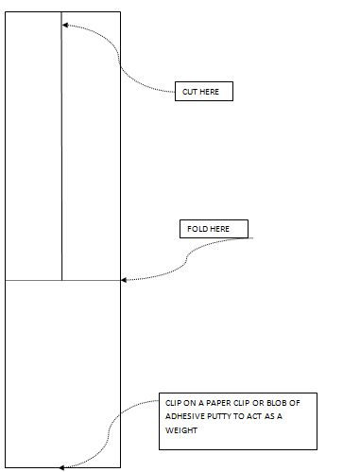
Fig 4 Helicopter template

